WEEK 9 – DBSE
REST API – GET and POST Operations

GET Request
[
{
"id": 1,
"name": "Laptop",
"description": "HP Victus Laptop",
"price": 55000.0,
"quantity": 5
},
{
"id": 2,
"name": "Laptop",
"description": "HP Laptop Belong to Vedika",
"price": 35000.0,
"quantity": 5
}
]

GET OUTPUT
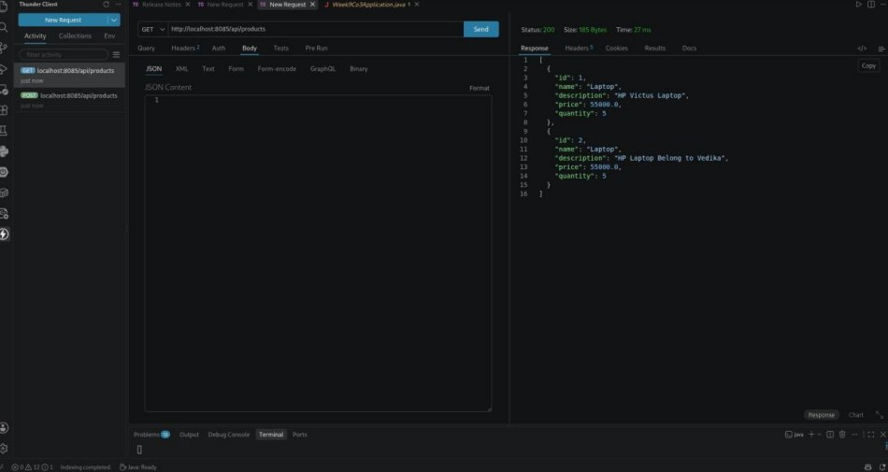

2. POST Request

Request Body (JSON)
{
"name": "Laptop",
"description": "HP Laptop Belong to Vedika",
"price": 55000,
"quantity": 5
}

POST OUTPUT
